C. ABDUL HAKEEM COLLEGE OF ENGINEERING AND
TECHNOLOGY, MELVISHARAM.
Hakeem Nagar, Melvisharam - 632 509, Ranipet District, Tamil Nadu, India. (Approved by AICTE, New Delhi and Affiliated to Anna University, Chennai)
(Regd. Under Sec 2(F) & 12(B) of the UGC Act 1956)


DEPARTMENT OF ARTIFICIAL INTELLIGENCE AND DATA SCIENCE
AD3511 – DEEP LEARNING RECORD
(REGULATION - 2021)

Name of the Student:

Register Number:

Degree / Branch:

Year / Semester:

Academic Year:

C. ABDUL HAKEEM COLLEGE OF ENGINEERING AND TECHNOLOGY
Hakeem Nagar, Melvisharam - 632 509, Ranipet District, Tamil Nadu, India.
(Approved by AICTE, New Delhi and Affiliated to Anna University, Chennai)
Regd. Under Sec 2(F) & 12(B) of the UGC Act 1956)

Name of the Candidate:

Year: III Semester: V Degree/Branch: B. TECH/AIDS

Subject Code: AD3511
Subject Name: DEEP LEARNING
University Register Number:

CERTIFICATE

Certified that this is the bonafide record of work done by the above student in
AD3511 – DEEP LEARNING
during 2024 - 2025.

Signature of Lab In-charge Signature of Head of the Department

Submitted for the University Practical Examination held on ________________
EXAMINERS

Date: Centre code: 5106

Internal: External:

TABLE OF CONTENTS

EXP  NO | DATE | EXPERIMENT TITLE | PAGE NO | MARK | SIGNATURE

Ex. No: 1 A | SOLVING XOR PROBLEM USING DNN
Date : | SOLVING XOR PROBLEM USING DNN

Aim:
To write a python program to Solving XOR problem using DNN.

Algorithm:
Import required modules
Assign X(input) and y(output)
Assign the model to Sequential() function
Add hidden layer with the use of Dense() function
Compile and fit the model
Calculate the Loss and Accuracy
Print the Predicted output

Program:

import numpy as np
import tensorflow as tf
from tensorflow.keras.models import Sequential
from tensorflow.keras.layers import Dense

#input and target
X=np.array([[0, 0], [0, 1], [1, 0], [1, 1]])
y=np.array([[0], [1], [1], [0]])

#building the model
model=Sequential()
#Adding the dense value for the hidden layer
model.add(Dense(8,input_dim=2,activation='relu'))
model.add(Dense(1,activation='sigmoid'))

#compileing the model
model.compile(loss='binary_crossentropy',optimizer='adam',metrics=['accuracy'])

#fitting the input and target into the model
model.fit(X,y,epochs=1000)

#calculating the loss and accuracy
loss,accuracy=model.evaluate(X,y)
print(f"Loss:{loss:.4f},Accuracy:{accuracy:.4f}")

#predicting the values
predictions=model.predict(X)
print("Predictions:")
for i in range(len(X)):
print(f"Input:{X[i]},Predicted Output:{predictions[i][0]:.4f}")

Output

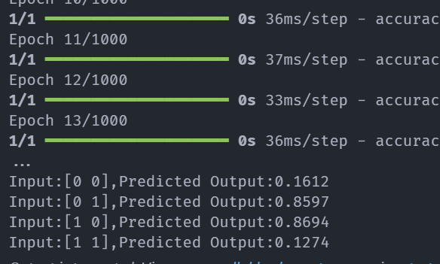

Result:
Thus the above python program to work with XOR logic using DNN has been executed successfully and the output is displayed
Exp No : 1 B  Date : | AND LOGIC USING DNN

AIM:

To write a python program to solve AND logic using DNN.

ALGORITHM:

Import required modules
Assign X(input) and y(output)
Assign the model to Sequential() function
Add hidden layer with the use of Dense() function
Compile and fit the model
Calculate the Loss and Accuracy
Print the Predicted output

Program

import numpy as np
import tensorflow as tf
from tensorflow.keras.models import Sequential
from tensorflow.keras.layers import Dense

#input and target
X=np.array([[0, 0], [0, 1], [1, 0], [1, 1]])
y=np.array([[0], [0], [0], [1]])

#building the model
model=Sequential()

#Adding the dense value for the hidden layer
model.add(Dense(8,input_dim=2,activation='relu'))
model.add(Dense(1,activation='sigmoid'))

#compileing the model
model.compile(loss='binary_crossentropy',optimizer='adam',metrics=['accuracy'])

#fitting the input and target into the model
model.fit(X,y,epochs=1000)

#calculating the loss and accuracy
loss,accuracy=model.evaluate(X,y)
print(f"Loss:{loss:.4f},Accuracy:{accuracy:.4f}")

#predicting the values
predictions=model.predict(X)
print("Predictions:")
for i in range(len(X)):
print(f"Input:{X[i]},Predicted Output:{predictions[i][0]:.4f}")

Output

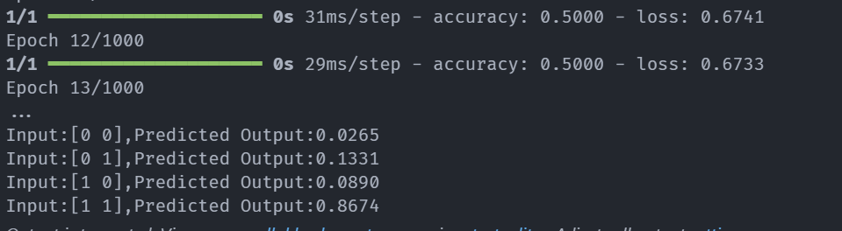

RESULT:
Thus the above python program to work with AND logic using DNN has been executed successfully and the output is displayed.

Ex. No: 1 C | OR LOGIC USING DNN
Date : | OR LOGIC USING DNN
AIM:

To write a python program to solve OR logic using DNN.

ALGORITHM:

Import required modules
Assign X(input) and y(output)
Assign the model to Sequential() function
Add hidden layer with the use of Dense() function
Compile and fit the model
Calculate the Loss and Accuracy
Print the Predicted output

Program

import numpy as np
import tensorflow as tf
from tensorflow.keras.models import Sequential
from tensorflow.keras.layers import Dense

#input and target
X=np.array([[0, 0], [0, 1], [1, 0], [1, 1]])
y=np.array([[0], [1], [1], [1]])

#building the model
model=Sequential()

#Adding the dense value for the hidden layer
model.add(Dense(8,input_dim=2,activation='relu'))
model.add(Dense(1,activation='sigmoid'))

#compileing the model
model.compile(loss='binary_crossentropy',optimizer='adam',metrics=['accuracy'])

#fitting the input and target into the model
model.fit(X,y,epochs=1000)
#calculating the loss and accuracy
loss,accuracy=model.evaluate(X,y)
print(f"Loss:{loss:.4f},Accuracy:{accuracy:.4f}")

#predicting the values
predictions=model.predict(X)

print("Predictions:")

for i in range(len(X)):
print(f"Input:{X[i]},Predicted Output:{predictions[i][0]:.4f}")

Output

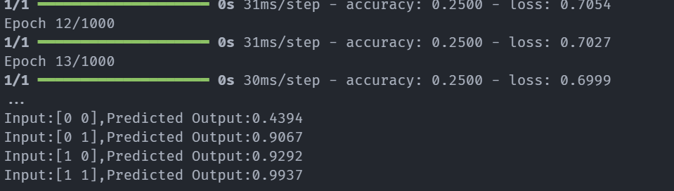

RESULT
Thus the above python program to work with OR logic using DNN has been executed successfully and the output is displayed

Ex. No: 2 | FACE RECOGNITION USING CNN
Date : | FACE RECOGNITION USING CNN

Aim:
To write a python program to implement the Face recognition using CNN.

Algorithm:
Start the program.
Get the relevant packages for Face Recognition
Load the LFW dataset from the sklearn library.
Reshape data for model creation
Train the model and Prediction on test data
Prediction on External Image
Stop the program

Program:
import numpy as np
import pandas as pd
from sklearn.datasets import fetch_lfw_people
from sklearn.model_selection import train_test_split
from sklearn.metrics import confusion_matrix
import matplotlib.pyplot as plt
import seaborn as sns
from keras.layers import Dense, Conv2D, MaxPooling2D, Flatten
from keras.models import Sequential
from keras.utils import to_categorical
from keras.preprocessing import image

faces = fetch_lfw_people(min_faces_per_person=10, resize=1.0,
slice_=(slice(60, 188), slice(60, 188)), color=True)

fig, ax = plt.subplots(3, 6, figsize=(18, 10))
for i, axi in enumerate(ax.flat):
axi.imshow(faces.images[i])
axi.set(xticks=[], yticks=[], xlabel=faces.target_names[faces.target[i]])

Output:
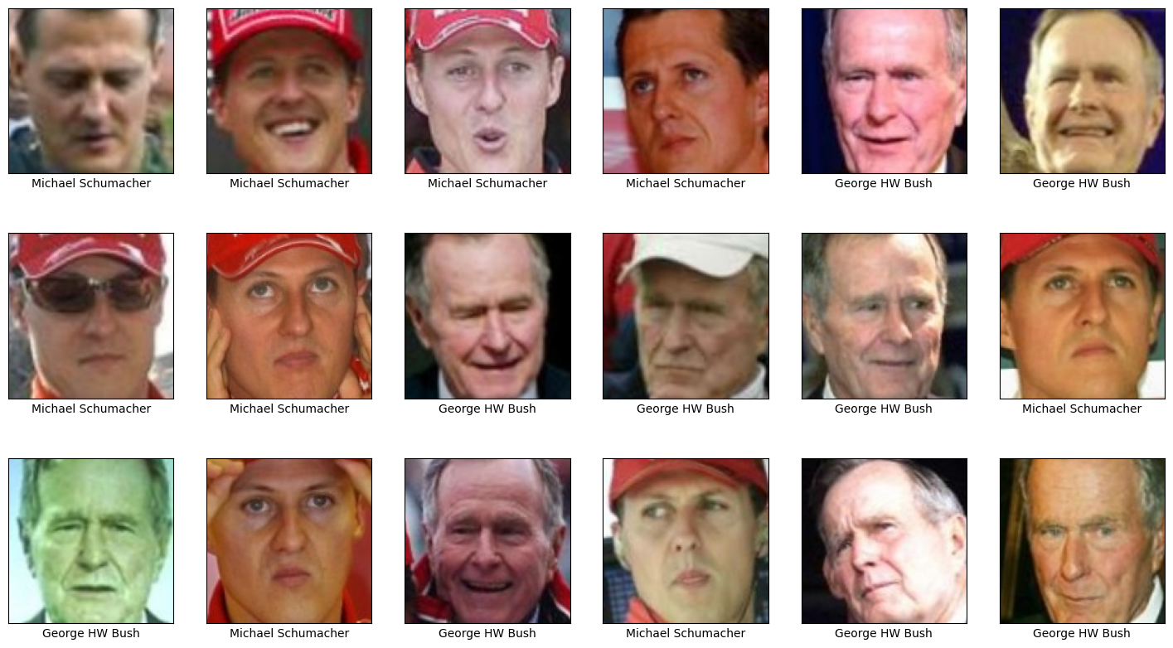

mask = np.zeros(faces.target.shape, dtype=bool)
for target in np.unique(faces.target):
mask[np.where(faces.target == target)[0][:100]] = 1

x_faces = faces.data[mask]
y_faces = faces.target[mask]
x_faces = np.reshape(x_faces, (x_faces.shape[0], faces.images.shape[1],
faces.images.shape[2], faces.images.shape[3]))
face_images = x_faces / 255
face_labels = to_categorical(y_faces)
x_train, x_test, y_train, y_test = train_test_split(
face_images, face_labels, train_size=0.8, stratify=face_labels, random_state=0
)
model = Sequential()
model.add(Conv2D(32, (3, 3), activation='relu', input_shape=(face_images.shape[1:])))
model.add(MaxPooling2D(2, 2))
model.add(Conv2D(64, (3, 3), activation='relu'))
model.add(MaxPooling2D(2, 2))
model.add(Conv2D(64, (3, 3), activation='relu'))
model.add(MaxPooling2D(2, 2))
model.add(Flatten())
model.add(Dense(128, activation='relu'))
model.add(Dense(len(faces.target_names), activation='softmax'))
# Compile the model
model.compile(optimizer='adam', loss='categorical_crossentropy', metrics=['accuracy'])
model.summary()

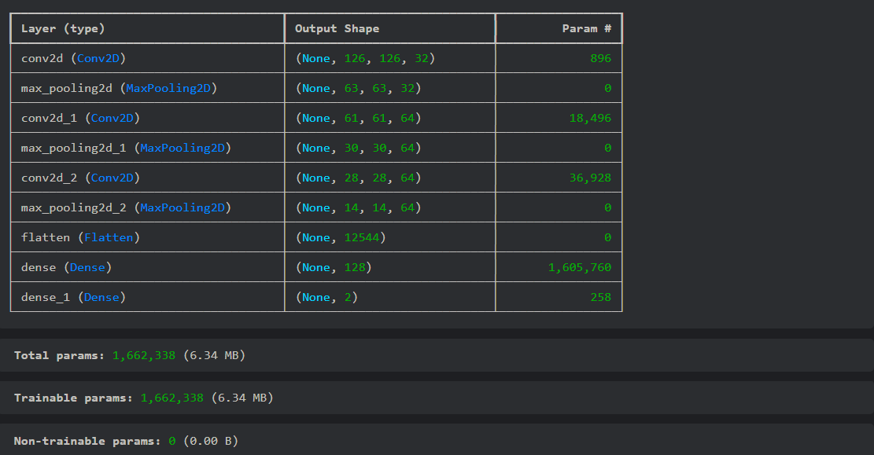

hist = model.fit(x_train, y_train, validation_data=(x_test, y_test), epochs=20, batch_size=25)

Output:
Epoch 1/20
1/1 ━━━━━━━━━━━━━━━━━━━━ 1s 936ms/step - accuracy: 0.3750 - loss: 0.6932 - val_accuracy: 0.5714 - val_loss: 0.6915
Epoch 2/20
1/1 ━━━━━━━━━━━━━━━━━━━━ 0s 87ms/step - accuracy: 0.5833 - loss: 0.6912 - val_accuracy: 0.5714 - val_loss: 0.6861
Epoch 3/20
1/1 ━━━━━━━━━━━━━━━━━━━━ 0s 83ms/step - accuracy: 0.5833 - loss: 0.6844 - val_accuracy: 0.5714 - val_loss: 0.6840
Epoch 4/20
1/1 ━━━━━━━━━━━━━━━━━━━━ 0s 82ms/step - accuracy: 0.5833 - loss: 0.6792 - val_accuracy: 0.5714 - val_loss: 0.6952
Epoch 5/20
1/1 ━━━━━━━━━━━━━━━━━━━━ 0s 81ms/step - accuracy: 0.5833 - loss: 0.6873 - val_accuracy: 0.5714 - val_loss: 0.6862
Epoch 6/20
1/1 ━━━━━━━━━━━━━━━━━━━━ 0s 80ms/step - accuracy: 0.5833 - loss: 0.6804 - val_accuracy: 0.5714 - val_loss: 0.6831
Epoch 7/20
1/1 ━━━━━━━━━━━━━━━━━━━━ 0s 80ms/step - accuracy: 0.5833 - loss: 0.6792 - val_accuracy: 0.5714 - val_loss: 0.6837
Epoch 8/20
1/1 ━━━━━━━━━━━━━━━━━━━━ 0s 94ms/step - accuracy: 0.5833 - loss: 0.6809 - val_accuracy: 0.5714 - val_loss: 0.6844

acc = hist.history['accuracy']
val_acc = hist.history['val_accuracy']
epochs = range(1, len(acc) + 1)
plt.plot(epochs, acc, '-', label='Training Accuracy')
plt.plot(epochs, val_acc, ':', label='Validation Accuracy')
plt.title('Training and Validation Accuracy')
plt.xlabel('Epoch')
plt.ylabel('Accuracy')
plt.legend(loc='lower right')
plt.show()
Output:
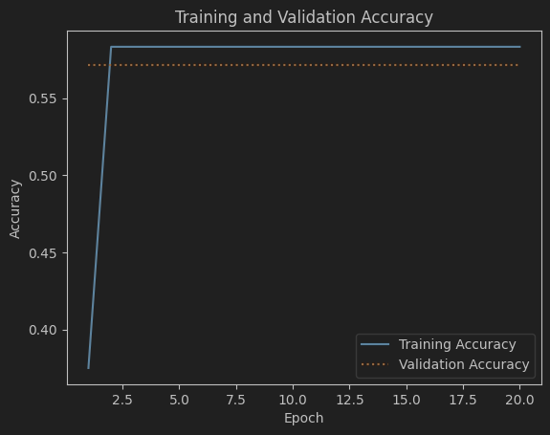

y_predicted = model.predict(x_test)

1/1 ━━━━━━━━━━━━━━━━━━━━ 0s 52ms/step

mat = confusion_matrix(y_test.argmax(axis=1), y_predicted.argmax(axis=1))

sns.heatmap(mat.T, square=True, annot=True, fmt='d', cbar=False,
cmap='Blues', xticklabels=faces.target_names, yticklabels=faces.target_names)
plt.xlabel('Predicted label')
plt.ylabel('Actual label')
plt.show()

Output:
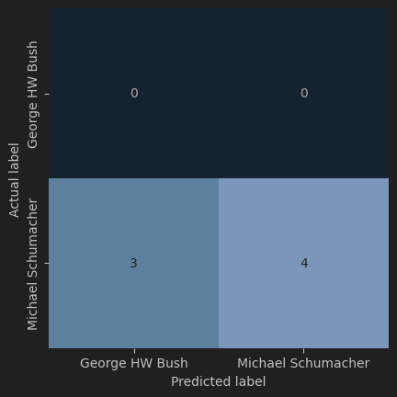

x = image.load_img('george.jpg', target_size=(face_images.shape[1:]))
plt.xticks([])
plt.yticks([])
plt.imshow(x)
Output:
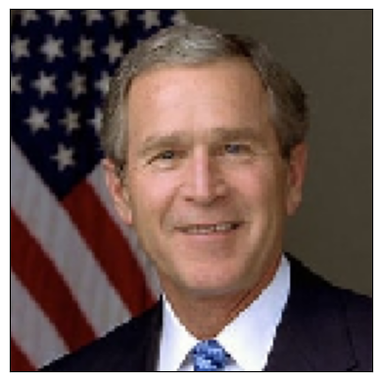
x = image.img_to_array(x) / 255
x = np.expand_dims(x, axis=0)
y = model.predict(x)[0]
for i in range(len(y)):
print(f"{faces.target_names[i]}: {y[i]}")

Output:
1/1 ━━━━━━━━━━━━━━━━━━━━ 0s 51ms/step
George HW Bush: 0.025578858330845833
Michael Schumacher: 0.9744210839271545

Result:
Thus written a python program to implement successfully for the Character recognition using CNN.

Ex. No: 3 | CHARACTER RECOGNITION USING CNN
Date: | CHARACTER RECOGNITION USING CNN
Aim:
To write a python program to implement the Character recognition using CNN.

Algorithm:
- Start the program.
- Get the relevant packages for Character Recognition
- Load the A_Z Handwritten Data.csv from the directory.
- Reshape data for model creation
- Train the model and Prediction on test data
- Prediction on External Image s
- Stop the program

Program:
import cv2
import numpy as np
import pandas as pd
import matplotlib.pyplot as plt
from sklearn.model_selection import train_test_split
from sklearn.utils import shuffle
import keras
from keras.models import Sequential
from keras.layers import Dense,Flatten,Conv2D ,MaxPool2D,Dropout
from keras.optimizers import SGD,Adam
from keras.callbacks import ReduceLROnPlateau,EarlyStopping
from keras.utils import to_categorical
data=pd.read_csv(r"C:\Users\3AI1\Downloads\archive\A_Z Handwritten Data.csv").astype('float32')
x=data.drop('0',axis=1)
y=data['0']
trainX,testX,trainY,testY=train_test_split(x,y,test_size=0.2)
trainY=to_categorical(trainY,num_classes=26)
testY=to_categorical(testY,num_classes=26)
trainX=np.reshape(trainX.values,(trainX.shape[0],28,28))
testX=np.reshape(testX.values,(testX.shape[0],28,28))
model=Sequential(
[
Conv2D(filters=32,kernel_size=(3,3),activation='relu',input_shape=(28,28,1)),
MaxPool2D(pool_size=(2,2),strides=2),
Conv2D(filters=64,kernel_size=(3,3),activation='relu',padding='same'),
Conv2D(filters=128,kernel_size=(3,3),activation='relu',padding='valid'),
MaxPool2D(pool_size=(2,2),strides=2),
Flatten(),
Dense(64,activation='relu'),
Dense(128,activation='relu'),
Dense(26,activation='softmax')
]
)

Output:

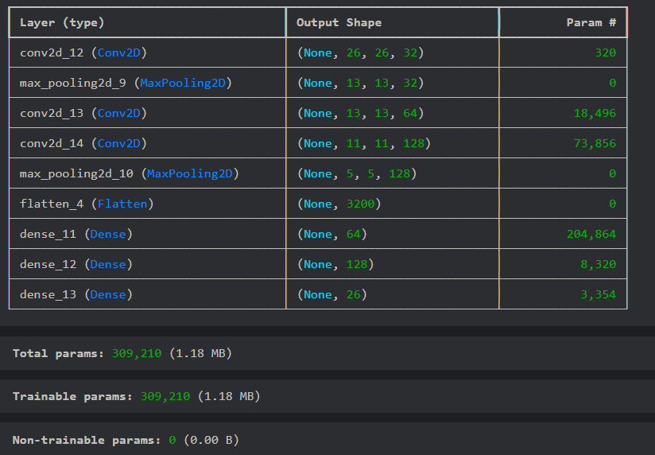

model.compile(optimizer=Adam(learning_rate=0.001),loss='categorical_crossentropy',metrics=
['accuracy'])
history=model.fit(trainX,trainY,epochs=1,batch_size=64,validation_data=(testX,testY))

4656/4656 ━━━━━━━━━━━━━━━━━━━━ 53s 11ms/step - accuracy: 0.8878 - loss: 0.5290 - val_accuracy: 0.9786 - val_loss: 0.0760

model.save(r'model_hand.h5')
#%%
img=testX[20]
plt.imshow(img.reshape(28,28))

Output:

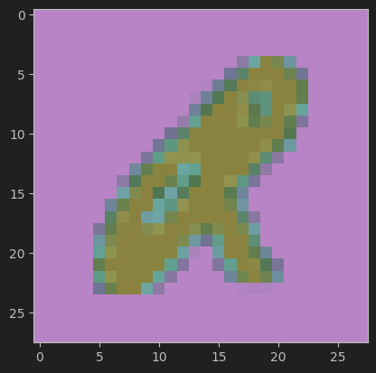

img=testX[200]
image_array = img / 255.0
image_array = np.reshape(image_array, (1, 28, 28, 1))
predicted_class = model.predict(image_array)
predicted_label = np.argmax(predicted_class, axis=1)
alphabet = 'ABCDEFGHIJKLMNOPQRSTUVWXYZ'
predicted_char = alphabet[predicted_label[0]]
print(f"Predicted letter: {predicted_char}")
plt.imshow(image_array.reshape(28, 28), cmap='gray')
plt.title(f"Predicted: {predicted_char}")
plt.show()

Output:

1/1 ━━━━━━━━━━━━━━━━━━━━ 0s 14ms/step
Predicted letter: T

Output:
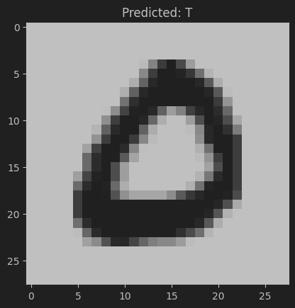

Result:
Thus written a python program to implemented successfully for the Face recognition using CNN.

Ex. No: 4 | LANGUAGE MODELING USING RNN
Date : | LANGUAGE MODELING USING RNN

Aim:
To write a python program to implement the Language modeling using RNN.

Algorithm:
- Start the program.
- Get the relevant packages for Language modeling
- Read a file and split into lines.
- Build the category_lines dictionary, a list of lines per category
- Add the Random item from a list
- Get a random category and random line from that category.
- One-hot vector for category
- Make category, input, and target tensors from a random category, line pair
- Sample from a category and starting letter
- Get multiple samples from one category and multiple starting letters.
- Train the model and Prediction on test data
- Prediction on External Image
- Stop the program

Program:
from keras.models import Sequential
from keras.layers import Embedding, LSTM, Dense ,SimpleRNN
from tensorflow.keras.preprocessing.text import Tokenizer
from keras.preprocessing.sequence import pad_sequences
from keras.utils import to_categorical
import numpy as np

# Example text data
text_data = [
"The quick brown fox jumps over the lazy dog.",
"A journey of a thousand miles begins with a single step.",
"To be or not to be, that is the question.",
"All that glitters is not gold.",
"In the end, we will remember not the words of our enemies, but the silence of our friends."
]

# Preprocess the data
tokenizer = Tokenizer()
tokenizer.fit_on_texts(text_data)
total_words = len(tokenizer.word_index) + 1
input_sequences = []
for line in text_data:
token_list = tokenizer.texts_to_sequences([line])[0]

for i in range(1, len(token_list)):
n_gram_sequence = token_list[:i+1]
input_sequences.append(n_gram_sequence)
max_sequence_length = max([len(seq) for seq in input_sequences])
input_sequences = pad_sequences(input_sequences, maxlen=max_sequence_length,
padding='pre')

X, y = input_sequences[:, :-1], input_sequences[:, -1]
y = to_categorical(y, num_classes=total_words)
# Build RNN Model
model = Sequential()
model.add(Embedding(total_words, 100, input_length=max_sequence_length-1))
model.add(LSTM(100))
model.add(Dense(total_words, activation='softmax'))
model.compile(optimizer='adam', loss='categorical_crossentropy', metrics=['accuracy'])
# Train the Model
model.fit(X, y, epochs=100, verbose=2)

Output:
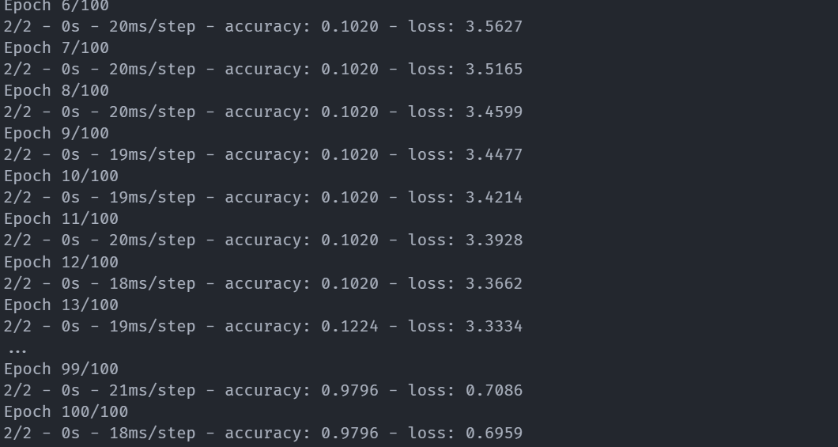
# Generate Text
seed_text = "The"
next_words = 10
for _ in range(next_words):
token_list = tokenizer.texts_to_sequences([seed_text])[0]
token_list = pad_sequences([token_list], maxlen=max_sequence_length-1, padding='pre')

predicted_probs = model.predict(token_list, verbose=0)
predicted_index = np.argmax(predicted_probs)
output_word = ""
for word, index in tokenizer.word_index.items():
if index == predicted_index:
output_word = word
break
seed_text += " " + output_word
print(“Generated Text : \n”,seed_text)
Output:
Generated Text:
The quick brown fox jumps over the lazy dog

Result:
Thus written a python program to implemented successfully for the Language Modeling Using RNN

Ex. No: 5 | SENTIMENT ANALYSIS USING LSTM
Date : | SENTIMENT ANALYSIS USING LSTM
Aim:
To write a python program to implement the Sentiment analysis using LSTM.

Algorithm:
- Start the program.
- Get the relevant packages for Keras-Preprocessing
- Load the IMDB Dataset.csv file.
- Remove HTML tags, URL and non-alphanumeric characters
- Read a file and split into lines.
- Tuning the hyperparameters of the model
- Model initialization compile model reviews on which we need to predict.
- Stop the program

Program:
import pandas as pd
import numpy as np
from keras.models import Sequential
from keras.layers import Embedding, LSTM, Dense
from tensorflow.keras.preprocessing.text import Tokenizer
from keras_preprocessing.sequence import pad_sequences
from sklearn.model_selection import train_test_split
# Load data
data = pd.read_csv('./Train/Train.csv')
# data['sentiment'] = data['label'].map({'positive': 1, 'negative': 0})
# Tokenization and padding
tokenizer = Tokenizer(num_words=5000)
tokenizer.fit_on_texts(data['text'])
X = pad_sequences(tokenizer.texts_to_sequences(data['text']), maxlen=200)
y = data['label'].values
# Train-test split
X_train, X_test, y_train, y_test = train_test_split(X, y, test_size=0.2)
# LSTM model
model = Sequential([
Embedding(input_dim=5000, output_dim=128, input_length=200),
LSTM(128),
Dense(1, activation='sigmoid')
])
# Compile and train
model.compile(optimizer='adam', loss='binary_crossentropy', metrics=['accuracy'])
model.fit(X_train, y_train, epochs=5, validation_data=(X_test, y_test))
#%%
# Function to preprocess input text for prediction
def preprocess_text(text, tokenizer, maxlen=200):
sequence = tokenizer.texts_to_sequences([text]) # Tokenize text
padded_sequence = pad_sequences(sequence, maxlen=maxlen, padding='post', truncating='post') # Pad sequence
return padded_sequence
# Predict function
def predict_sentiment(text, model, tokenizer):
processed_text = preprocess_text(text, tokenizer)
prediction = model.predict(processed_text) # Model returns probability
sentiment = "positive" if prediction[0][0] >= 0.5 else "negative"
return sentiment, prediction[0][0]
# Example usage
sample_text = "The movie was fantastic and very enjoyable!"
sentiment, confidence = predict_sentiment(sample_text, model, tokenizer)
print(f"Text: {sample_text}")
print(f"Sentiment: {sentiment}")
print(f"Confidence: {confidence:.4f}")
Output:
1000/1000 ━━━━━━━━━━━━━━━━━━━━ 105s 103ms/step - accuracy: 0.7391 - loss: 0.5044 - val_accuracy: 0.7844 - val_loss: 0.4634
Epoch 2/5
1000/1000 ━━━━━━━━━━━━━━━━━━━━ 113s 113ms/step - accuracy: 0.8627 - loss: 0.3288 - val_accuracy: 0.8848 - val_loss: 0.2973
Epoch 3/5
1000/1000 ━━━━━━━━━━━━━━━━━━━━ 65s 65ms/step - accuracy: 0.9096 - loss: 0.2340 - val_accuracy: 0.8766 - val_loss: 0.3101
Epoch 4/5
1000/1000 ━━━━━━━━━━━━━━━━━━━━ 66s 66ms/step - accuracy: 0.9297 - loss: 0.1806 - val_accuracy: 0.8924 - val_loss: 0.2731
Epoch 5/51000/1000 ━━━━━━━━━━━━━━━━━━━━ 65s 64ms/step - accuracy: 0.9455 - loss: 0.1458 - val_accuracy: 0.8907 - val_loss: 0.2920

# Function to preprocess input text for prediction
def preprocess_text(text, tokenizer, maxlen=200):
sequence = tokenizer.texts_to_sequences([text]) # Tokenize text
padded_sequence = pad_sequences(sequence, maxlen=maxlen, padding='post', truncating='post') # Pad sequence
return padded_sequence
# Predict function
def predict_sentiment(text, model, tokenizer):
processed_text = preprocess_text(text, tokenizer)
prediction = model.predict(processed_text) # Model returns probability
sentiment = "positive" if prediction[0][0] >= 0.5 else "negative"
return sentiment, prediction[0][0]
# Example usage
sample_text = "The movie was fantastic and very enjoyable!"
sentiment, confidence = predict_sentiment(sample_text, model, tokenizer)
print(f"Text: {sample_text}")
print(f"Sentiment: {sentiment}")
print(f"Confidence: {confidence:.4f}")

Output:
1/1 ━━━━━━━━━━━━━━━━━━━━ 0s 32ms/step
Text: The movie was fantastic and very enjoyable!
Sentiment: positive
Confidence: 0.5664

Result:
Thus written a python program to implemented successfully for the Sentiment analysis using LSTM.

Ex. No: 6 | PARTS OF SPEECH TAGGING USING SEQUENCE TO SEQUENCE ARCHITECTURE
Date :
Aim:
To write a python program to implement the parts of speech tagging using Sequence to Sequence architecture.

Algorithm:
- Start the program
- Get the relevant packages for functiontools
- Load the Vocabulary Creation and data split in to train and test
- Sort the vocabulary by occurrences of words write the sorted vocabulary to vocab file
- build a vocabulary list with only frequent words (i.e. occur no less than 3 times) replace non-frequent words in word with <unk> make sure the index of the current word is less than the next build an emission and a transition dictionaries
- write the emission and transition dictionaries into a json file load txt file vocab
- split dev lists (index, word and pos) to individual samples (list --> list of sublists) initialize a dictionary that keeps track of the highest cumulative probability of each possible pos at each position of the input sentence
- use viterbi to predict pos for dev
- merge the list of sublists to single list
- Stop the program

Program:
import numpy as np
from tensorflow.keras.models import Model
from tensorflow.keras.layers import Input, Embedding, LSTM, Dense
from tensorflow.keras.preprocessing.text import Tokenizer
from tensorflow.keras.preprocessing.sequence import pad_sequences
from sklearn.model_selection import train_test_split
# Sample data: sentences and corresponding POS tags
# Updated dataset
sentences = [
"The cat sat on the mat",
"She sells sea shells on the seashore",
"He is reading a book",
"They were playing football yesterday",
"The sun rises in the east",
"I enjoy coding and learning new technologies",
"Birds are chirping in the morning",
"The car stopped at the signal",
"He loves eating pizza and pasta",
"The children are studying for their exams",
]
tags = [
"DET NOUN VERB ADP DET NOUN",
"PRON VERB NOUN NOUN ADP DET NOUN",
"PRON AUX VERB DET NOUN",
"PRON AUX VERB NOUN NOUN",
"DET NOUN VERB ADP DET NOUN",
"PRON VERB VERB CONJ VERB ADJ NOUN",
"NOUN AUX VERB ADP DET NOUN",
"DET NOUN VERB ADP DET NOUN",
"PRON VERB VERB NOUN CONJ NOUN",
"DET NOUN AUX VERB ADP DET NOUN",
]
# Tokenizer for words and tags
word_tokenizer = Tokenizer()
tag_tokenizer = Tokenizer()
# Fit the tokenizers
word_tokenizer.fit_on_texts(sentences)
tag_tokenizer.fit_on_texts(tags)
# Convert sentences and tags to sequences
X = word_tokenizer.texts_to_sequences(sentences)
y = tag_tokenizer.texts_to_sequences(tags)
# Add <START> and <END> tokens to the tag vocabulary
tag_tokenizer.word_index["<START>"] = len(tag_tokenizer.word_index) + 1
tag_tokenizer.word_index["<END>"] = len(tag_tokenizer.word_index) + 1
# Pad sequences
max_len = max(len(seq) for seq in X) # Max length of sequences
X = pad_sequences(X, maxlen=max_len, padding="post")
y = pad_sequences(y, maxlen=max_len, padding="post")
# Convert to numpy arrays
y = np.array(y)
# Split data into train and test sets
X_train, X_test, y_train, y_test = train_test_split(X, y, test_size=0.2, random_state=42)
# Define hyperparameters
num_words = len(word_tokenizer.word_index) + 1 # Vocabulary size for words
num_tags=len(tag_tokenizer.word index) + 1 # Vocabulary size for tags
embedding_dim = 128
hidden_units = 128
# Encoder
encoder_inputs = Input(shape=(max_len,))
encoder_embedding = Embedding(input_dim=num_words, output_dim=embedding_dim)(encoder_inputs)
encoder_lstm, state_h, state_c = LSTM(hidden_units, return_state=True)(encoder_embedding)
encoder_states = [state_h, state_c]
# Decoder
decoder_inputs = Input(shape=(max_len,))
decoder_embedding_layer = Embedding(input_dim=num_tags, output_dim=embedding_dim)
decoder_embedding = decoder_embedding_layer(decoder_inputs)
decoder_lstm = LSTM(hidden_units, return_sequences=True, return_state=True)
decoder_outputs, _, _ = decoder_lstm(decoder_embedding, initial_state=encoder_states)
decoder_dense = Dense(num_tags, activation="softmax")
decoder_outputs = decoder_dense(decoder_outputs)
# Define the seq2seq model
model = Model([encoder_inputs, decoder_inputs], decoder_outputs)
model.compile(optimizer="adam", loss="sparse_categorical_crossentropy", metrics=["accuracy"])
# Prepare decoder inputs and outputs
decoder_input_data = np.zeros_like(y_train)
decoder_input_data[:, 1:] = y_train[:, :-1] # Shifted by one position
decoder_output_data = np.expand_dims(y_train, -1) # Expand dimensions for sparse_categorical_crossentropy
# Train the model
model.fit(
[X_train, decoder_input_data],
decoder_output_data,
batch_size=32,
epochs=50,
validation_split=0.2,
)
# Define inference models
# Encoder inference model
encoder_model = Model(encoder_inputs, encoder_states)
# Decoder inference model
decoder_state_input_h = Input(shape=(hidden_units,))
decoder_state_input_c = Input(shape=(hidden_units,))
decoder_states_inputs = [decoder_state_input_h, decoder_state_input_c]
decoder_inputs_infer = Input(shape=(1,))
decoder_embedding_infer = decoder_embedding_layer(decoder_inputs_infer)
decoder_lstm_infer, state_h, state_c = decoder_lstm(decoder_embedding_infer, initial_state=decoder_states_inputs)
decoder_states_infer = [state_h, state_c]
decoder_outputs_infer = decoder_dense(decoder_lstm_infer)
decoder_model = Model(
[decoder_inputs_infer] + decoder_states_inputs,
[decoder_outputs_infer] + decoder_states_infer,
)
# Function for POS tagging inference
def predict_pos(sentence):
# Convert input sentence to sequence
seq = word_tokenizer.texts_to_sequences([sentence])
seq = pad_sequences(seq, maxlen=max_len, padding="post")
# Encode the input sentence
states = encoder_model.predict(seq)
# Initialize the target sequence with <START> token
target_seq = np.zeros((1, 1))
target_seq[0, 0] = tag_tokenizer.word_index["<START>"]
result = []
for _ in range(max_len):
# Predict the next token
output_tokens, h, c = decoder_model.predict([target_seq] + states)
# Get the token index with the highest probability
sampled_token_index = np.argmax(output_tokens[0, -1, :])
sampled_tag = tag_tokenizer.index_word.get(sampled_token_index, "<OOV>")
# Append to the result
result.append(sampled_tag)
# Break if <END> token is predicted
if sampled_tag == "<END>":
break
# Update the target sequence and states
target_seq[0, 0] = sampled_token_index
states = [h, c]
return result
# Test the model with a new sentence
new_sentence = "My name is Kishor"
tags = predict_pos(new_sentence)
print(f"Sentence: {new_sentence}")
print(f"Predicted POS Tags: {tags}")

Output:
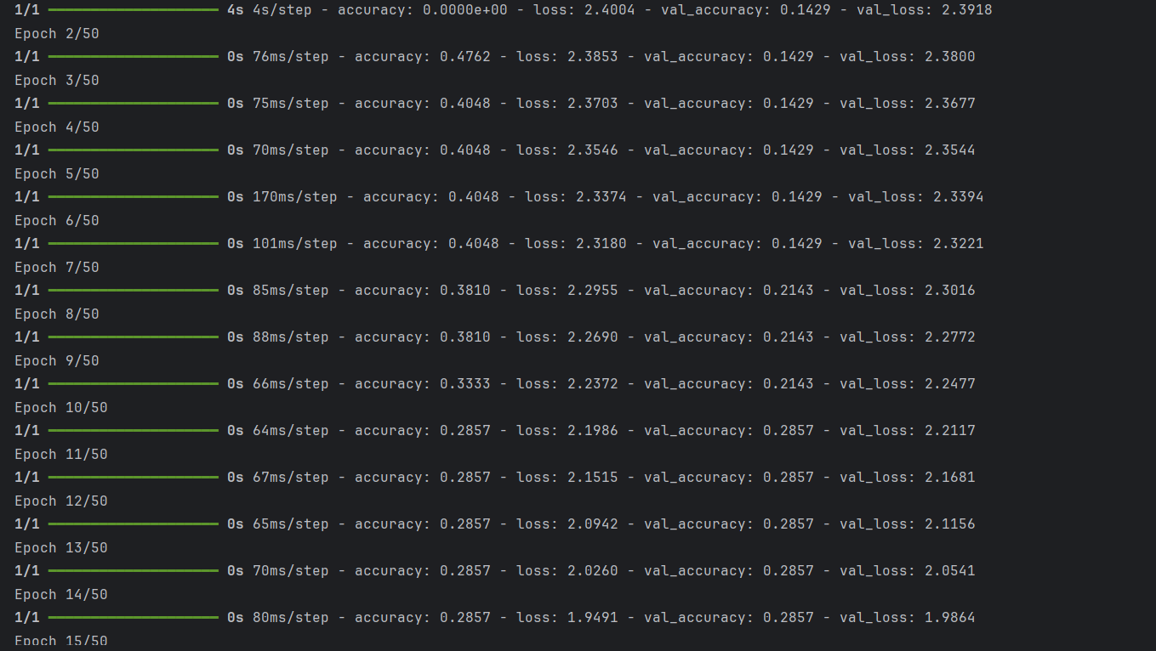

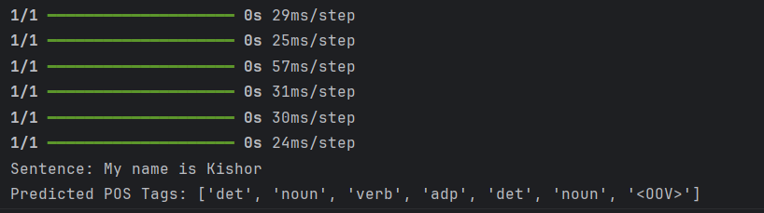

Result:
Thus written a python program to implemented successfully for the parts of speech tagging using Sequence to Sequence architecture.

Ex. No: 7 | MACHINE TRANSLATION USING ENCODER-DECODER MODEL
Date : | MACHINE TRANSLATION USING ENCODER-DECODER MODEL

Aim:
To write a python program to implement the Machine Translation using Encoder-Decoder model

Algorithm:
- Start the program
- Input data files are available in the read-only
- Decoder_target_data is ahead of decoder_input_data by one timestep
- Set up the decoder, using `encoder_states` as initial state
- Run training
- Reverse-lookup token index to decode sequences back to something readable.
- Generate empty target sequence of length 1.
- Sampling loop for a batch of sequences (to simplify, here we assume a batch of size 1).
- Sample a token
- Exit condition: either hit max length or find stop character.
- Update the target sequence (of length 1).
- Update states
- Stop the program

Program:
from tensorflow.keras.preprocessing.text import Tokenizer
import tensorflow as tf
from tensorflow.keras.preprocessing.sequence import pad_sequences
from tensorflow.keras.models import Model
from tensorflow.keras.layers import Input, Embedding, LSTM, Dense, Attention, Concatenate

english_sentences = [
"Good morning! How are you today?",
"I am feeling great, thank you for asking.",
"Can you help me with this task?",
"Where are you going this weekend?",
"Please pass me the salt.",
"I don't understand what you're saying.",
"It was nice meeting you.",
"Have a great day ahead!",
"Can I borrow your pen?",
"What time is the meeting?",
"I am going to the market.",
"She is a very good friend of mine.",
"Are you free this evening?",
"I need to finish my homework.",
"Let's meet up tomorrow."
]

tamil_sentences = [
"<start> காலை வணக்கம்! இன்று எப்படி இருக்கிறீர்கள்? <end>",
"<start> நான் சிறப்பாக உணர்கிறேன், கேள்வி கேட்டதற்கு நன்றி. <end>",
"<start> நீங்கள் இந்த பணி உதவி செய்ய முடியுமா? <end>",
"<start> நீங்கள் இந்த வாரம் இறுதியில் எங்கு போகிறீர்கள்? <end>",
"<start> தயவுசெய்து உப்பை எனக்கு அனுப்பவும். <end>",
"<start> நான் நீங்கள் சொல்லும் விஷயத்தை புரிந்துகொள்ளவில்லை. <end>",
"<start> உங்களை சந்திப்பதில் மகிழ்ச்சி. <end>",
"<start> இனிய நாள் வாழ்த்துக்கள்! <end>",
"<start> நான் உங்களின் பேனை கடன் கொள்ளலாமா? <end>",
"<start> கூட்டம் எத்தனை மணிக்கு? <end>",
"<start> நான் சந்தைக்கு போகிறேன். <end>",
"<start> அவள் எனது மிகவும் நல்ல நண்பி. <end>",
"<start> நீங்கள் இன்று மாலை காலம் நேரம் இருக்கிறீர்களா? <end>",
"<start> எனக்கு என் வீட்டுப் பணி முடிக்க வேண்டும். <end>",
"<start> நாளை சந்திப்போம். <end>"
]

# Tokenize and pad the sequences
tokenizer_eng = Tokenizer()
tokenizer_eng.fit_on_texts(english_sentences)
eng_sequences = tokenizer_eng.texts_to_sequences(english_sentences)
eng_sequences_padded = pad_sequences(eng_sequences, padding='post')

tokenizer_tam = Tokenizer()
tokenizer_tam.fit_on_texts(tamil_sentences)
tam_sequences = tokenizer_tam.texts_to_sequences(tamil_sentences)
tam_sequences_padded = pad_sequences(tam_sequences, padding='post')

# Define vocabulary sizes
vocab_size_eng = len(tokenizer_eng.word_index) + 1
vocab_size_tam = len(tokenizer_tam.word_index) + 1

# Define model parameters
embedding_dim = 256
hidden_units = 512
num_epochs = 100
batch_size = 64

# Build the Encoder model
encoder_inputs = Input(shape=(None,))
encoder_embedding = Embedding(input_dim=vocab_size_eng, output_dim=embedding_dim)(encoder_inputs)
encoder_outputs, state_h, state_c = LSTM(hidden_units, return_sequences=True, return_state=True)(encoder_embedding)
encoder_states = [state_h, state_c]
# Build the Decoder model
decoder_inputs = Input(shape=(None,))
decoder_embedding = Embedding(input_dim=vocab_size_tam, output_dim=embedding_dim)(decoder_inputs)
decoder_lstm = LSTM(hidden_units, return_sequences=True, return_state=True)
decoder_outputs, _, _ = decoder_lstm(decoder_embedding, initial_state=encoder_states)

# Add Attention Mechanism
attention_layer = Attention()
attention_output = attention_layer([decoder_outputs, encoder_outputs])
decoder_combined_context = Concatenate(axis=-1)([attention_output, decoder_outputs])

# Generate Output
decoder_dense = Dense(vocab_size_tam, activation='softmax')
decoder_outputs = decoder_dense(decoder_combined_context)

# Define the Model
model = Model([encoder_inputs, decoder_inputs], decoder_outputs)

# Compile the model
model.compile(optimizer='adam', loss='sparse_categorical_crossentropy', metrics=['accuracy'])

# Prepare target sequences for training
decoder_input_data = tam_sequences_padded[:, :-1]
decoder_target_data = tam_sequences_padded[:, 1:]

# Train the model
model.fit(
[eng_sequences_padded,decoder_input_data],decoder_target_data,epochs=num_epochs,
batch_size=batch_size )

Output
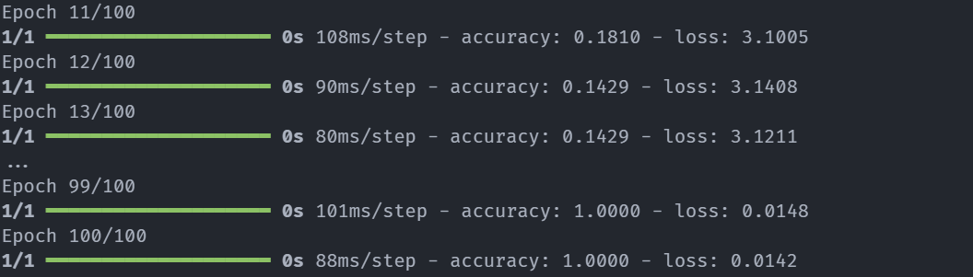

def translate_sentence(sentence, model, tokenizer_eng, tokenizer_tam, max_seq_length):

# Tokenize and pad the input sentence
input_sequence = tokenizer_eng.texts_to_sequences([sentence])
input_sequence_padded = pad_sequences(input_sequence, maxlen=max_seq_length, padding='post')

# Get the start and end tokens for French
start_token = tokenizer_tam.word_index.get('start', None)
end_token = tokenizer_tam.word_index.get('end', None)

# Initialize the decoder input sequence with the start token
decoder_input_sequence = np.array([[start_token]])

translated_sentence = []

for _ in range(max_seq_length): # Limit translation to max sequence length
# Predict the next word
predictions = model.predict([input_sequence_padded, decoder_input_sequence], verbose=0)

predicted_word_index = np.argmax(predictions[0, -1, :])

# Check for end token
if predicted_word_index == end_token:
break

# Skip zero indices (padding)
if predicted_word_index == 0:
continue

# Get the predicted word (French translation)
predicted_word = tokenizer_tam.index_word.get(predicted_word_index, None)

# Append the predicted word to the translated sentence
translated_sentence.append(predicted_word)

# Update the decoder input sequence with the predicted word
decoder_input_sequence = np.append(decoder_input_sequence, [[predicted_word_index]], axis=1)

# Join and return the translated sentence
return ' '.join(translated_sentence)

# Test the model with a new sentence
sentence = "Good morning! How are you today?"
translated = translate_sentence(sentence, model, tokenizer_eng, tokenizer_tam, max_seq_length=eng_sequences_padded.shape[1])
print(f"English: {sentence}")
print(f"Tamil: {translated}\n")

Output

English: Good morning! How are you today?

Tamil: காலை வணக்கம் இன்று எப்படி இருக்கிறீர்கள்

Result:
Thus written a python program to implemented successfully for the Machine Translation using Encoder-Decoder model.

Ex. No: 8 | IMAGE AUGMENTATION USING GANS
Date : | IMAGE AUGMENTATION USING GANS

Aim:
To write a python program to implement the Image augmentation using GANs
Algorithm:
- Start the program
- Load the images from the directory.
- Split the data into train and test images
- Training the CNN using the two different sized datasets with no augmented data. Train a network based on ResNet-50V2 with data augmentation Preprocess the image and submit it to the network for classification.
- Now try it with a walrus image that the network hasn't seen before. Start by loading the image.
- Finally, Preprocess the image and make a prediction.
- Stop the program.

Program:
import glob
import imageio
import matplotlib.pyplot as plt
import numpy as np
import os
import PIL
import tensorflow as tf
from tensorflow.keras import layers
import time
from IPython import display
#%%
(train_images, train_labels), (_, _) = tf.keras.datasets.mnist.load_data()
train_images = train_images.reshape(train_images.shape[0], 28, 28, 1).astype('float32')
train_images = (train_images - 127.5) / 127.5 # Normalize the images to [-1, 1]
BUFFER_SIZE = 60000
BATCH_SIZE = 256
# Batch and shuffle the data
train_dataset = tf.data.Dataset.from_tensor_slices(train_images).shuffle(BUFFER_SIZE).batch(BATCH_SIZE)
def make_generator_model():
model = tf.keras.Sequential()
model.add(layers.Dense(7*7*256, use_bias=False, input_shape=(100,)))
model.add(layers.BatchNormalization())
model.add(layers.LeakyReLU())
model.add(layers.Reshape((7, 7, 256)))
assert model.output_shape == (None, 7, 7, 256) # Note: None is the batch size
model.add(layers.Conv2DTranspose(128, (5, 5), strides=(1, 1), padding='same', use_bias=False))
assert model.output_shape == (None, 7, 7, 128)
model.add(layers.BatchNormalization())
model.add(layers.LeakyReLU())
model.add(layers.Conv2DTranspose(64, (5, 5), strides=(2, 2), padding='same', use_bias=False))
assert model.output_shape == (None, 14, 14, 64)
model.add(layers.BatchNormalization())
model.add(layers.LeakyReLU())
model.add(layers.Conv2DTranspose(1, (5, 5), strides=(2, 2), padding='same', use_bias=False, activation='tanh'))
assert model.output_shape == (None, 28, 28, 1)
return model
generator = make_generator_model()
generator.summary()
Output:
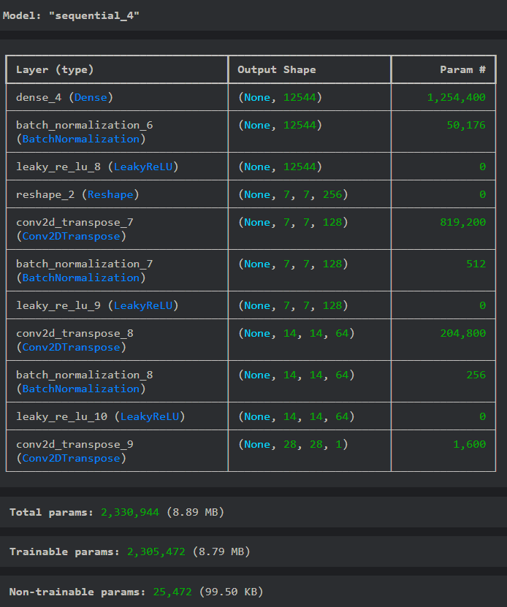

noise = tf.random.normal([1, 100])
generated_image = generator(noise, training=False)
plt.imshow(generated_image[0, :, :, 0], cmap='gray')

Output:
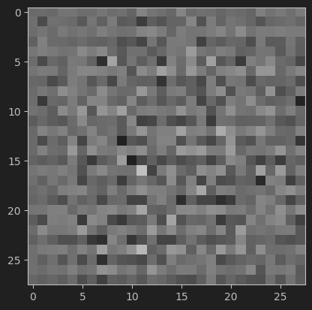

def make_discriminator_model():
model = tf.keras.Sequential()
model.add(layers.Conv2D(64, (5, 5), strides=(2, 2), padding='same',
input_shape=[28, 28, 1]))
model.add(layers.LeakyReLU())
model.add(layers.Dropout(0.3))
model.add(layers.Conv2D(128, (5, 5), strides=(2, 2), padding='same'))
model.add(layers.LeakyReLU())
model.add(layers.Dropout(0.3))
model.add(layers.Flatten())
model.add(layers.Dense(1))
return model
discriminator = make_discriminator_model()
discriminator.summary()

Output:
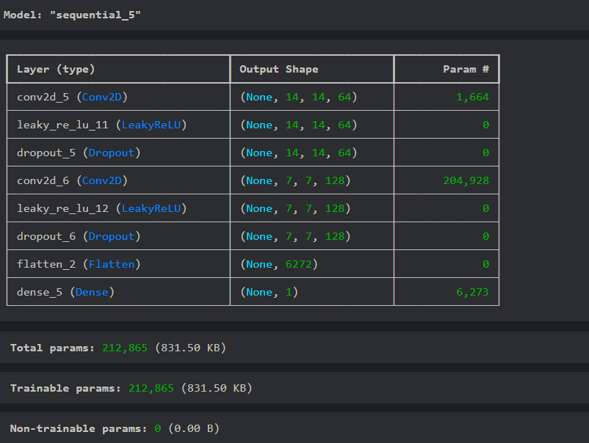

decision = discriminator(generated_image)
print (decision)

Output:

cross_entropy = tf.keras.losses.BinaryCrossentropy(from_logits=True)
def discriminator_loss(real_output, fake_output):
real_loss = cross_entropy(tf.ones_like(real_output), real_output)
fake_loss = cross_entropy(tf.zeros_like(fake_output), fake_output)
total_loss = real_loss + fake_loss
return total_loss
def generator_loss(fake_output):
return cross_entropy(tf.ones_like(fake_output), fake_output)
generator_optimizer = tf.keras.optimizers.Adam(1e-4)
discriminator_optimizer = tf.keras.optimizers.Adam(1e-4)
EPOCHS = 10
noise_dim = 100
num_examples_to_generate = 16
# We will reuse this seed overtime (so it's easier)
# to visualize progress in the animated GIF)
seed = tf.random.normal([num_examples_to_generate, noise_dim])
checkpoint_dir = './training_checkpoints'
checkpoint_prefix = os.path.join(checkpoint_dir, "ckpt")
checkpoint = tf.train.Checkpoint(generator_optimizer=generator_optimizer,
discriminator_optimizer=discriminator_optimizer,
generator=generator,
discriminator=discriminator)
@tf.function
def train_step(images):
noise = tf.random.normal([BATCH_SIZE, noise_dim])
with tf.GradientTape() as gen_tape, tf.GradientTape() as disc_tape:
generated_images = generator(noise, training=True)
real_output = discriminator(images, training=True)
fake_output = discriminator(generated_images, training=True)
gen_loss = generator_loss(fake_output)
disc_loss = discriminator_loss(real_output, fake_output)
gradients_of_generator = gen_tape.gradient(gen_loss, generator.trainable_variables)
gradients_of_discriminator = disc_tape.gradient(disc_loss, discriminator.trainable_variables)
generator_optimizer.apply_gradients(zip(gradients_of_generator, generator.trainable_variables))
discriminator_optimizer.apply_gradients(zip(gradients_of_discriminator, discriminator.trainable_variables))
def train(dataset, epochs):
for epoch in range(epochs):
start = time.time()
for image_batch in dataset:
train_step(image_batch)
# Produce images for the GIF as we go
display.clear_output(wait=True)
generate_and_save_images(generator,
epoch + 1,
seed)
# Save the model every 15 epochs
if (epoch + 1) % 15 == 0:
checkpoint.save(file_prefix = checkpoint_prefix)
print ('Time for epoch {} is {} sec'.format(epoch + 1, time.time()-start))
# Generate after the final epoch
display.clear_output(wait=True)
generate_and_save_images(generator,
epochs,
seed)
def generate_and_save_images(model, epoch, test_input):
# Notice `training` is set to False.
# This is so all layers run in inference mode (batchnorm).
predictions = model(test_input, training=False)
fig = plt.figure(figsize=(4,4))
for i in range(predictions.shape[0]):
plt.subplot(4, 4, i+1)
plt.imshow(predictions[i, :, :, 0] * 127.5 + 127.5, cmap='gray')
plt.axis('off')
plt.savefig('image_at_epoch_{:04d}.png'.format(epoch))
plt.show()
time
train(train_dataset, EPOCHS)

Output:
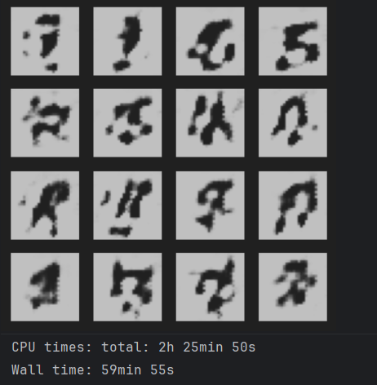

checkpoint.restore(tf.train.latest_checkpoint(checkpoint_dir))
anim_file = 'DCGAN_Animation.gif'
with imageio.get_writer(anim_file, mode='I') as writer:
filenames = glob.glob('image*.png')
filenames = sorted(filenames)
last = -1
for i,filename in enumerate(filenames):
frame = 2*(i**0.5)
if round(frame) > round(last):
last = frame
else:
continue
image = imageio.imread(filename)
writer.append_data(image)
image = imageio.imread(filename)
writer.append_data(image)
import IPython
if IPython.version_info > (6,2,0,''):
display.Image(filename=anim_file)
noise = tf.random.normal([1, 100])
generated_image = generator(noise, training=False)
plt.imshow(generated_image[0, :, :, 0], cmap='gray')

Output:

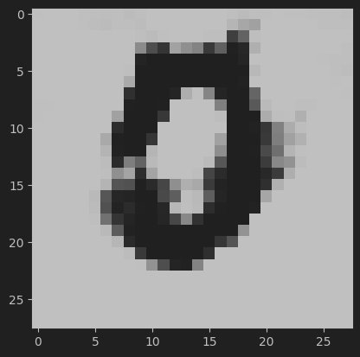

Result:
Thus written a python program to implemented successfully for the Image augmentation using GANs.

MINI PROJECTS

Image classification using cifar-10 dataset

Code Snippets
(X_train, y_train), (X_test, y_test) = cifar10.load_data()
# Scale the data
X_train = X_train / 255.0
X_test = X_test / 255.0
# Transform target variable into one-hotencoding
y_cat_train = to_categorical(y_train, 10)
y_cat_test = to_categorical(y_test, 10)
INPUT_SHAPE = (32, 32, 3)
KERNEL_SIZE = (3, 3)
model = Sequential()

# Convolutional Layer
model.add(Conv2D(filters=32, kernel_size=KERNEL_SIZE, input_shape=INPUT_SHAPE, activation='relu', padding='same'))
model.add(BatchNormalization())
model.add(Conv2D(filters=32, kernel_size=KERNEL_SIZE, input_shape=INPUT_SHAPE, activation='relu', padding='same'))
model.add(BatchNormalization())
# Pooling layer
model.add(MaxPool2D(pool_size=(2, 2)))
# Dropout layers
model.add(Dropout(0.25))
model.add(Conv2D(filters=64, kernel_size=KERNEL_SIZE, input_shape=INPUT_SHAPE, activation='relu', padding='same'))
model.add(BatchNormalization())
model.add(Conv2D(filters=64, kernel_size=KERNEL_SIZE, input_shape=INPUT_SHAPE, activation='relu', padding='same'))
model.add(BatchNormalization())
model.add(MaxPool2D(pool_size=(2, 2)))
model.add(Dropout(0.25))
model.add(Conv2D(filters=128, kernel_size=KERNEL_SIZE, input_shape=INPUT_SHAPE, activation='relu', padding='same'))
model.add(BatchNormalization())
model.add(Conv2D(filters=128, kernel_size=KERNEL_SIZE, input_shape=INPUT_SHAPE, activation='relu', padding='same'))
model.add(BatchNormalization())
model.add(MaxPool2D(pool_size=(2, 2)))
model.add(Dropout(0.25))

model.add(Flatten())
# model.add(Dropout(0.2))
model.add(Dense(128, activation='relu'))
model.add(Dropout(0.25))
model.add(Dense(10, activation='softmax'))

METRICS = [
'accuracy',
tf.keras.metrics.Precision(name='precision'),
tf.keras.metrics.Recall(name='recall')
]
model.compile(loss='categorical_crossentropy', optimizer='adam', metrics=METRICS)
model.summary()
batch_size = 32
data_generator = ImageDataGenerator(width_shift_range=0.1, height_shift_range=0.1, horizontal_flip=True)
train_generator = data_generator.flow(X_train, y_cat_train, batch_size)
steps_per_epoch = X_train.shape[0] // batch_size

r = model.fit(train_generator,
epochs=50,
steps_per_epoch=steps_per_epoch,
validation_data=(X_test, y_cat_test), )
my_image = X_test[100]
plt.imshow(my_image)

# that's a Deer
print(f" Image 100 is {y_test[100]}")
pred_100 = np.argmax(model.predict(my_image.reshape(1, 32, 32, 3))
Output :
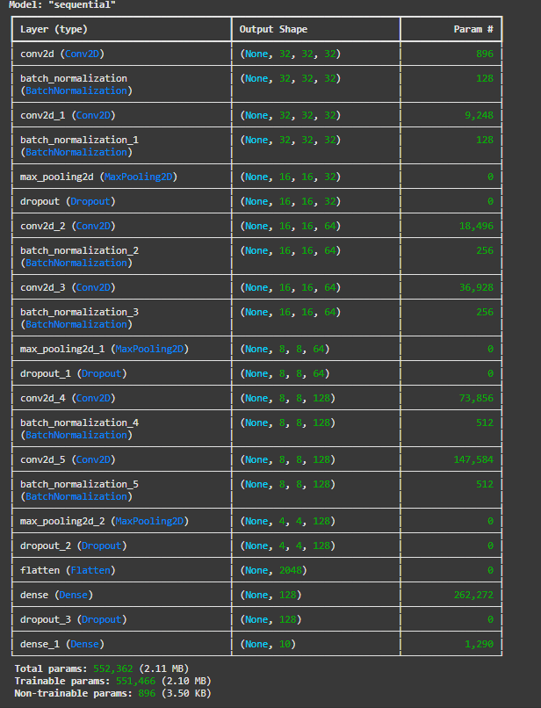
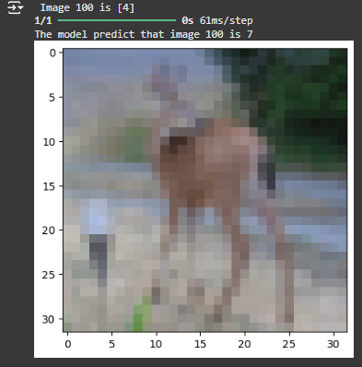
Leaf Disease Detection

Code Snippets
data_transforms =transforms.Compose([
transforms.Resize((224, 224)), transforms.RandomHorizontalFlip(), transforms.RandomRotation(20),
transforms.ToTensor(),transforms.Normalize([0.485, 0.456, 0.406], [0.229, 0.224, 0.225])
])
data_dir="./archive/plantvillagedataset/color"
image_datasets =datasets.ImageFolder(root=f"{data_dir}/", transform=data_transforms)
train_size = int(0.8 * len(image_datasets))
val_size = len(image_datasets) - train_size

train_dataset, val_dataset = random_split(image_datasets, [train_size, val_size])

train_loader = torch.utils.data.DataLoader(train_dataset, batch_size=batch_size, shuffle=True)
val_loader = torch.utils.data.DataLoader(val_dataset, batch_size=batch_size, shuffle=False)

classes=image_datasets.classes
model = models.resnet50(pretrained=True)
model.fc = nn.Linear(model.fc.in_features,len(classes))

model = model.to(device)
criterion = nn.CrossEntropyLoss()
optimizer = optim.SGD(model.parameters(), lr=learning_rate, momentum=0.9)
scheduler = torch.optim.lr_scheduler.ReduceLROnPlateau(optimizer, mode='max', patience=3, factor=0.1, verbose=True)

# Early stopping setup
patience = 5
best_val_acc = 0.0
epochs_no_improve = 0

def TrainModel(model, criterion, optimizer, scheduler, num_epochs=2, patience=5):
best_acc = 0.0
epochs_no_improve = 0
best_model_wts = model.state_dict()
for epoch in range(num_epochs):
print(f'Epoch {epoch + 1}/{num_epochs}')
print('-' * 1000)
model.train()
running_loss = 0.0
running_corrects = 0
dataset_size = len(train_loader.dataset)

for inputs, labels in train_loader:
inputs = inputs.to(device)
labels = labels.to(device)
print('In Training Loop.....')
print(labels)
optimizer.zero_grad()

outputs = model(inputs)
_, preds = torch.max(outputs, 1)

loss = criterion(outputs, labels)
loss.backward()
optimizer.step()

running_loss += loss.item() * inputs.size(0)
running_corrects += torch.sum(preds == labels.data)

epoch_loss = running_loss / dataset_size
epoch_acc = running_corrects.double() / dataset_size

print(f'Training Loss: {epoch_loss:.4f} Acc: {epoch_acc:.4f}')

model.eval()
val_running_corrects = 0
val_dataset_size = len(val_loader.dataset)
with torch.no_grad():
for inputs, labels in val_loader:
inputs = inputs.to(device)
labels = labels.to(device)
print('In Val Loop....')
print(labels)
outputs = model(inputs)
_, preds = torch.max(outputs, 1)
print('pred : ',preds)
val_running_corrects += torch.sum(preds == labels.data)

val_acc = val_running_corrects.double() / val_dataset_size
print(f'Validation Accuracy: {val_acc:.4f}'
scheduler.step(val_acc)
if val_acc > best_acc:
best_acc = val_acc
best_model_wts = model.state_dict()
epochs_no_improve = 0
else:
epochs_no_improve += 1
if epochs_no_improve >= patience:
print(f'Early stopping at epoch {epoch + 1}')
break
model.load_state_dict(best_model_wts)
print(f'Best val Acc: {best_acc:.4f}')
return model
model = TrainModel(model, criterion, optimizer, scheduler, num_epochs=num_epochs)
def predict_image(image_path, model, class_names):
image = Image.open(image_path)
image = data_transforms(image).unsqueeze(0)
image = image.to(device)
model.eval()
with torch.no_grad():
outputs = model(image)
_, preds = torch.max(outputs, 1)
class_idx = preds.item()
return class_names[class_idx]
test_image_path=r" plantvillagedataset\0ddd62cd-a999-4d58-a8f1-506e1004a595___RS_Early.B 8041.JPG"
predicted_class = predict_image(test_image_path, model, diseases)

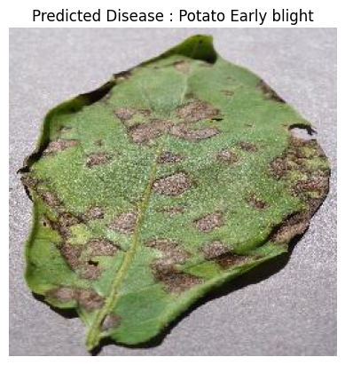
Hand Gesture Recognizer

Code Snippets
# initialize mediapipe
mpHands = mp.solutions.hands
hands = mpHands.Hands(max_num_hands=1, min_detection_confidence=0.7)
mpDraw = mp.solutions.drawing_utils
# Load the gesture recognizer model
model = load_model('mp_hand_gesture')
# Load class names
f = open('gesture.names','r')
classNames = f.read().split('\n')
f.close()
cap = cv2.VideoCapture(0)
while True:
_, frame = cap.read()
x, y, c = frame.shape

# Flip the frame vertically
frame = cv2.flip(frame, 1)
framergb = cv2.cvtColor(frame, cv2.COLOR_BGR2RGB)
# Get hand landmark prediction
result = hands.process(framergb)
className = ''
# post process the result
if result.multi_hand_landmarks:
landmarks = []
for handslms in result.multi_hand_landmarks:
for lm in handslms.landmark:
# print(id, lm)
lmx = int(lm.x * x)
lmy = int(lm.y * y)
landmarks.append([lmx, lmy])
# Drawing landmarks on frames
mpDraw.draw_landmarks(frame, handslms, mpHands.HAND_CONNECTIONS)
# Predict gesture
prediction = model.predict([landmarks])
# print(prediction)
classID = np.argmax(prediction)
className = classNames[classID]

# show the prediction on the frame
cv2.putText(frame, className, (10, 50), cv2.FONT_HERSHEY_SIMPLEX,
1, (0,0,255), 2, cv2.LINE_AA)

# Show the final output
cv2.imshow("Output", frame)

if cv2.waitKey(1) == ord('q'):
break

# release the webcam and destroy all active windows
cap.release()

cv2.destroyAllWindows()

Output

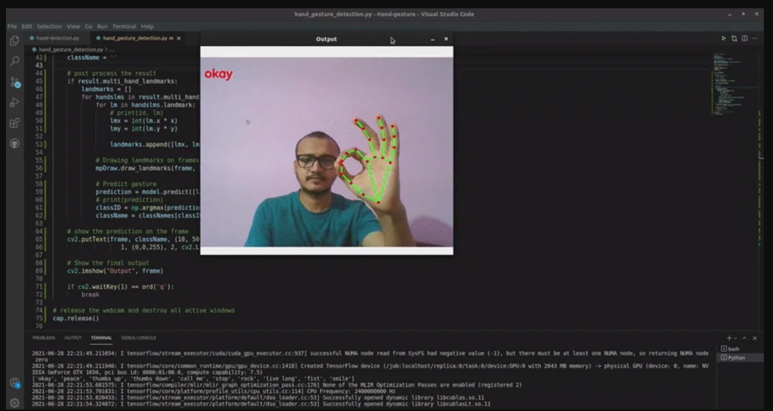

Face Emotion Recognition

Code Snippets

import cv2

from deepface import DeepFace

face_cascade = cv2.CascadeClassifier('face emotion detection in live camera.py')

cap = cv2.VideoCapture(0)

while True:

ret,frame = cap.read()

result = DeepFace.analyze(img_path = frame, actions=['emotion'],enforce_detection=False)

gray = cv2.cvtColor(frame,cv2.COLOR_BGR2GRAY)

faces = face_cascade.detectMultiScale(gray,1.1,4)

for (x,y,w,h) in faces:
cv2.rectangle(frame,(x,y),(x+w,y+h),(255,0,0),3)

emotion = result['dominant_emotion']

txt = str(emotion)

cv2.putText(frame,txt,(50,50),cv2.FONT_HERSHEY_SIMPLEX,1,(0,0,255),3)

cv2.imshow('frame',frame)

if cv2.waitkey(1) & 0xff == ort('q'):
break

cap.release()

cv2.destroyAllWindows()

Output

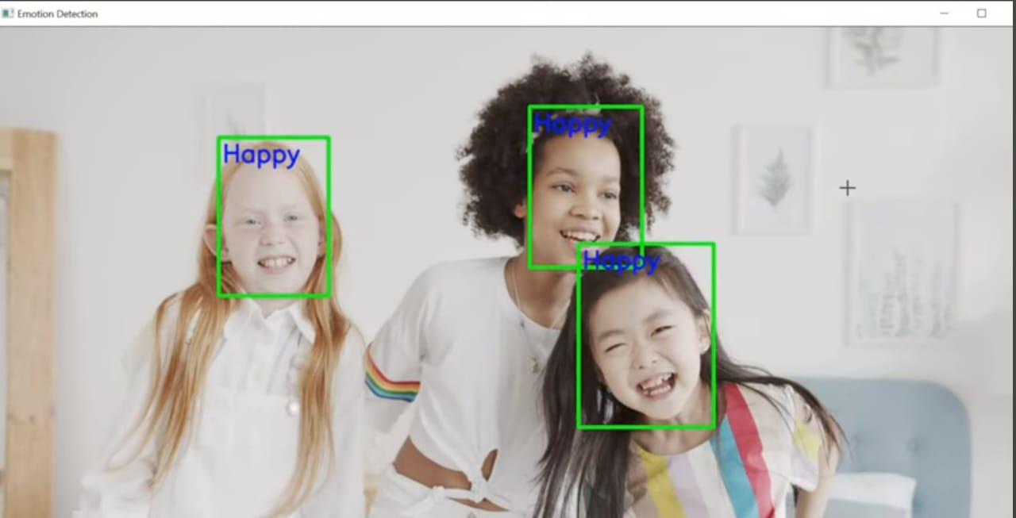

Music Genre Classification

Code Snippets
def extract_features(file_path, n_mfcc=40, max_pad_len=174):
try:
# Load the audio file
audio, sample_rate = librosa.load(file_path, res_type='kaiser_fast')
# Extract MFCCs
mfccs = librosa.feature.mfcc(y=audio, sr=sample_rate, n_mfcc=n_mfcc)

# Padding to ensure consistent length across all samples
pad_width = max_pad_len - mfccs.shape[1]
if pad_width > 0:
mfccs = np.pad(mfccs, pad_width=((0, 0), (0, pad_width)), mode='constant')
else:
mfccs = mfccs[:, :max_pad_len]

return mfccs

except Exception as e:
print(f"Error encountered while parsing file: {file_path}. Error: {str(e)}")
return None

data_path = r"C:\Users\3AI1\Desktop\Data" # Path to your dataset
genres = os.listdir(data_path) # List of subdirectories (genres)

X, y = [], []

# Iterate through each genre subdirectory
for genre in genres:
genre_path = os.path.join(data_path, genre)

# Skip system or hidden directories like .ipynb_checkpoints, .ipython, etc.
if genre.startswith('.') or not os.path.isdir(genre_path):
continue # Skip this folder

for file_name in os.listdir(genre_path):
file_path = os.path.join(genre_path, file_name)

# Check if the file is an audio file (you can expand this check)
if file_name.lower().endswith(('.wav', '.mp3', '.flac')):
features = extract_features(file_path)
if features is not None:
X.append(features)
y.append(genres.index(genre)) # Assign genre index as label

# Convert lists to numpy arrays
X = np.array(X)
y = np.array(y)

# One-hot encoding of labels
y = to_categorical(y, num_classes=len(genres))

# Split data into training and testing sets
X, y = [], []

# Iterate through each genre subdirectory
for genre in genres:
genre_path = os.path.join(data_path, genre)

if genre.startswith('.') or not os.path.isdir(genre_path):
continue # Skip hidden/system folders

for file_name in os.listdir(genre_path):
file_path = os.path.join(genre_path, file_name)

# Check if the file is an audio file
if file_name.lower().endswith(('.wav', '.mp3', '.flac')):
print(f"Processing: {file_path}") # Debugging: print the file being processed
features = extract_features(file_path)
if features is not None:
X.append(features)
y.append(genres.index(genre)) # Genre label
else:
print(f"Error: Features could not be extracted from {file_path}") # Debugging
else:
print(f"Skipping: {file_name}") # Debugging: file is not an audio file

print(f"Total samples: {len(X)}") # Debugging: number of features extracted
print(f"Total labels: {len(y)}") # Debugging: number of labels

if len(X) == 0 or len(y) == 0:
print("Error: No valid audio files found or features extracted.")
else:
# Convert lists to numpy arrays and one-hot encode labels
X = np.array(X)
y = np.array(y)
y = to_categorical(y, num_classes=len(genres))

# Split the data into training and testing sets
X_train, X_test, y_train, y_test = train_test_split(X, y, test_size=0.2, random_state=42)

if len(X) == 0 or len(y) == 0:
print("Error: No valid audio files found or features extracted.")
else:
# Convert lists to numpy arrays and one-hot encode labels
X = np.array(X)
y = np.array(y)
y = to_categorical(y, num_classes=len(genres))

# Split the data into training and testing sets
X_train, X_test, y_train, y_test = train_test_split(X, y, test_size=0.2, random_state=42)

# Reshape X_train and X_test for CNN input
X_train = X_train[..., np.newaxis] # Adding a new axis for channels (1 channel for grayscale)
X_test = X_test[..., np.newaxis] # Same for test set

# Now you can proceed with model training
model = Sequential([
Conv2D(32, (3, 3), activation='relu', input_shape=(40, 174, 1)),
MaxPooling2D((3, 3)),
Dropout(0.3),
Conv2D(64, (3, 3), activation='relu'),
MaxPooling2D((3, 3)),
Dropout(0.3),
Flatten(),
Dense(128, activation='relu'),
Dropout(0.3),
Dense(len(genres), activation='softmax')
])

model.compile(optimizer='adam', loss='categorical_crossentropy', metrics=['accuracy'])

# Train the model
model.fit(X_train, y_train, epochs=30, batch_size=32, validation_data=(X_test, y_test))

output

Language Translator

Code Snippets
lines = pd.read_csv("/kaggle/input/hindi-english-truncated-corpus/Hindi_English_Truncated_Corpus.csv")
encoder_input_data = np.zeros((len(input_texts), max_encoder_seq_length, num_encoder_tokens), dtype='float32')
decoder_input_data = np.zeros((len(input_texts), max_decoder_seq_length, num_decoder_tokens), dtype='float32')
decoder_target_data = np.zeros((len(input_texts), max_decoder_seq_length, num_decoder_tokens), dtype='float32')

batch_size = 128 # Batch size for training
epochs = 50 # Number of epochs to train for
latent_dim = 256
encoder_inputs = Input(shape=(None, num_encoder_tokens))
encoder = LSTM(latent_dim, return_state=True)
encoder_outputs, state_h, state_c = encoder(encoder_inputs)

# We discard `encoder_outputs` and only keep the states.
encoder_states = [state_h, state_c]
decoder_inputs = Input(shape=(None, num_decoder_tokens))

# We set up our decoder to return full output sequences,
# and to return internal states as well. We don't use the
# return states in the training model, but we will use them in inference.

decoder_lstm = LSTM(latent_dim, return_sequences=True, return_state=True)
decoder_outputs, _, _ = decoder_lstm(decoder_inputs, initial_state=encoder_states)

decoder_dense = Dense(num_decoder_tokens, activation='softmax')
decoder_outputs = decoder_dense(decoder_outputs)
model = Model([encoder_inputs, decoder_inputs], decoder_outputs)

# Run training
model.compile(optimizer='rmsprop', loss='categorical_crossentropy', metrics=['accuracy'])
model.fit([encoder_input_data, decoder_input_data], decoder_target_data,
batch_size=batch_size,
epochs=epochs,
validation_split=0.2,
callbacks=[cp_callback])
encoder_model = Model(encoder_inputs, encoder_states)

decoder_state_input_h = Input(shape=(latent_dim,))
decoder_state_input_c = Input(shape=(latent_dim,))

decoder_states_inputs = [decoder_state_input_h, decoder_state_input_c]
decoder_outputs, state_h, state_c = decoder_lstm(decoder_inputs, initial_state = decoder_states_inputs)

decoder_states = [state_h, state_c]
decoder_outputs = decoder_dense(decoder_outputs)

decoder_model = Model([decoder_inputs] + decoder_states_inputs, [decoder_outputs] + decoder_states)

for seq_index in range(100):
input_seq = encoder_input_data[seq_index: seq_index + 1]
decoded_sentence = decode_sequence(input_seq)
print('-')
print('Input sentence : ', input_texts[seq_index])
print('Decoded sentence : ', decoded_sentence)

Output


